[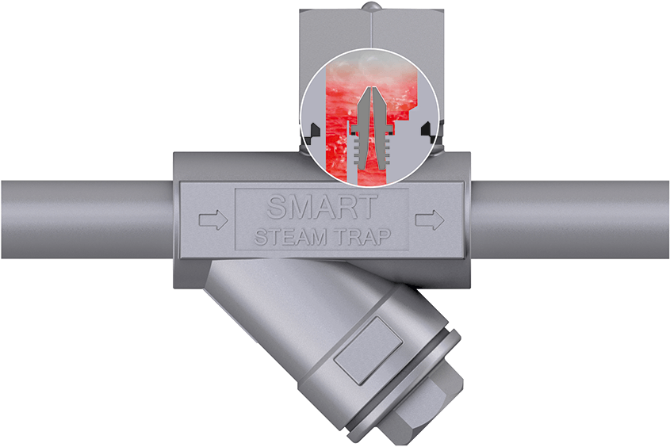](http://www.blueenergytechnologies.com/wp-content/uploads/2016/07/Smart-steam-trap-venturi-self_regulation.png) **STEAM SOLUTIONS LLP** Test Loation : …………….

|  |
| --- |
| **Questionnaire B : Introduction of ST Nozzle Type Steam Trap** |

|  |  |  |  |  |  |
| --- | --- | --- | --- | --- | --- |
| Existing Steam Trap | Maker | | |  | |
| Model | Trap Type | |  | |
| Model No. | |  | |
| Steam Trap Bore | | |  | |
| **STJ**  **Steam**  **Trap**  **Set Up**  **Point** | Steam Trap Setup Point (specific name, control code) | | |  | |
| For one batch operation (if batch operation is applicable) | Devices built on process line | |  | |
| Operating days per year | |  | Days/year |
| Average operating hours | |  | Hrs/year |
| Operation | |  | minutes |
| Idling | |  | minutes |
| Bore of piping connection point | | |  | |
| Branch pipe length (process device /main piping to steam trap) | | |  |  |
| Volume of discharged condensed water | At start up | Maximum |  | Kg/hr |
| Time required between start up to stable run | |  | Hr :min |
| In normal operation | maximum |  | Kg/hr |
| regular |  | Kg/hr |
| minimum |  | Kg/hr |
| Unit of pressure | MPa, kgf/cm2 | |  | |
| Before trap at primary side | Superheated steam or saturated steam | |  |  |
| Pressure | |  |  |
| Temperature | |  | C |
| After Trap at secondary side | Pressure | |  |  |
| Temperature | |  | C |
| Installation method | Screwed in, Flanged | |  | |
| (for Flange) | FTOF distance (mm, inch) | |  | |
| Standard | Screw, Flange Standard | |  | |

Submitted by : ………………………..